Clawdbot/Moltbot: Simple Daily Marketing Brief

Curate news from X, Reddit, and Hacker News
Nicolas Cole and Dickie Bush
Hey there!
In the last 48 hours, the internet has collectively lost its mind over Clawdbot (now Moltbot).
It’s being called “the greatest application of AI ever.”
- Bryan Johnson is tweeting about it.
- Forbes is covering it.
- The GitHub repo briefly got hijacked by crypto scammers because it was getting so much attention.
And if you’re curious about where AI is headed, this is worth understanding.
So today, I’m going to break down what Moltbot is, show you how people are using it to automate their lives, and walk you through how I built my first AI assistant — the AI Radar, a daily marketing briefing that scours Twitter, Reddit, and Hacker News for the best AI content and delivers it to my phone via Telegram every morning at 8am.
But first, a quick detour into why this thing has two names.

The Lobster Molted
Here’s a fun bit of internet history you’re witnessing in real-time.
This project was originally called Clawdbot, with a mascot named Clawd—a space lobster. (The AI community is weird.)
Then on January 27th, Anthropic sent the creator a polite email.
“Clawd” sounds a bit too much like “Claude”.
So what did the lobster do? It molted.
Molting is what lobsters do when they outgrow their shells. They shed it and grow a new one. Thus Molty was born—a.k.a. “Moltbot.”
So if you see “Clawdbot” in older tutorials it’s the same as Moltbot.

What Is Moltbot And Why Is It Different From Every Other AI Chatbot

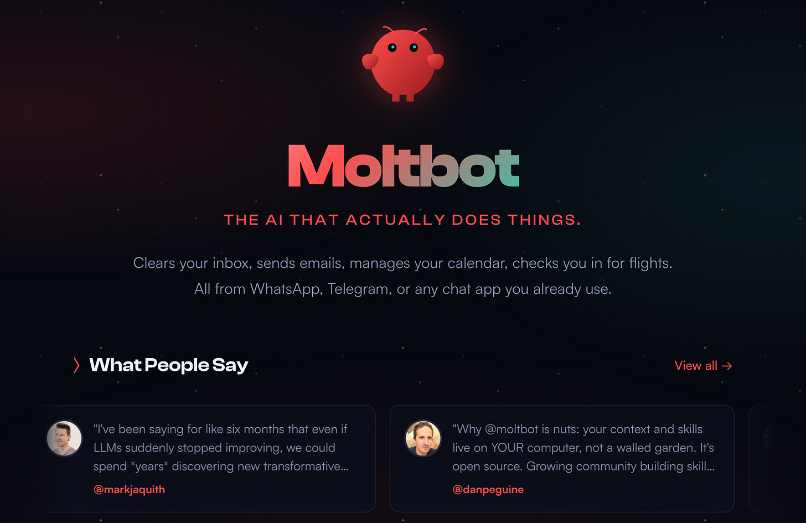

Moltbot is an open-source, self-hosted personal AI assistant created by Peter Steinberger that lives on your computer but is controlled entirely through your phone.
Unlike a standard chatbot where you have to stay in a browser tab, Clawdbot connects directly to your messaging apps—Telegram, WhatsApp, iMessage, or Discord. It has “infinite memory,” meaning it remembers your preferences, your past projects, and even your tone of voice.
But because it runs locally on your Mac, PC, or a cloud server your control, it has permission to open your browser, edit your files, and interact with your apps just like a human employee would.
You can be at a grocery store, realize you forgot to send a proposal, and text your bot: “Hey, find that PDF on my desktop and send it to John.”
Plus the more you talk to it, the “smarter” and more personalized it becomes.

What You Can Create With Moltbot
This is what got me excited enough to try it:
- Bio hacking: Logs your sleep, health, exercise data and tells you when you stay up too late
- “Second Brain” Manager: By connecting it to Notion or Obsidian, people are using it to organize messy voice notes into structured project boards without lifting a finger.
- Grocery Shopping: AI navigates the local Safeway grocery website, picks items, books delivery slots.
- E-com Assistant: People are asking their bots to monitor prices on Amazon or flight trackers and execute a purchase the moment a specific price target is hit.
- Morning Marketing Brief: Scans the news for trends, content ideas, and competitor analysis you should read based on your current objectives.
The Discord community is insane.
In 3 minutes, you’ll realize how much of your life you really can automate and you’ll be inspired to start tinkering.

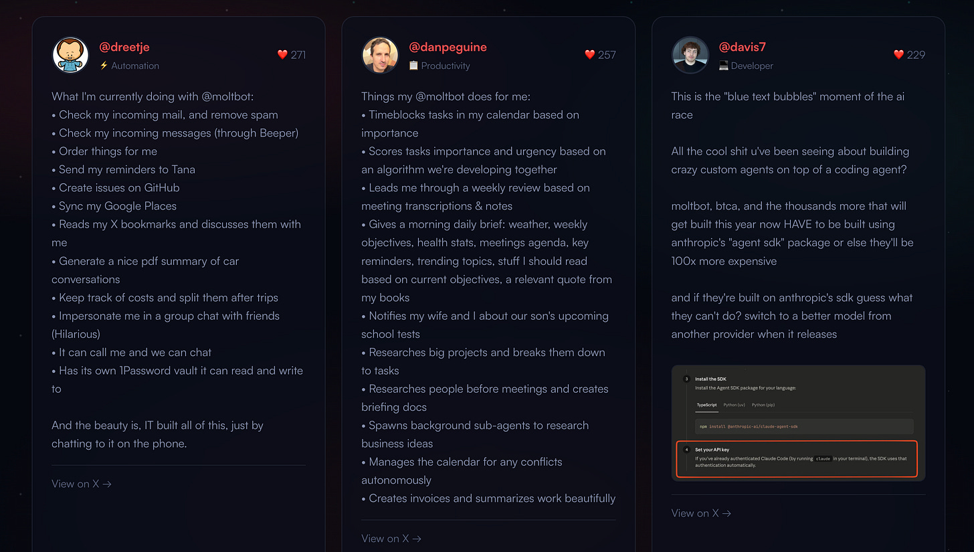

How To Get Started With Moltbot
The setup is easier than I expected.
Don’t let all the technical jargon deter you. All your doing is installing software on a computer in the cloud that’s private to you.
I used Hostinger because they have a one-click install.
Plus, you don’t have to worry about setting up a developer environment on your computer, or creating an Amazon EC2 instance, or rushing out to buy a $1,000 Mac Mini.
The whole process took me about 30 minutes. You’ll need is a basic Hostinger plan (~$6/month) to get started.
Click here for the instructions to install Moltbot on a Hostinger VPS.
Once you’ve installed Moltbot, you’ll be prompted to configure several environment variables including your Anthropic API Key, OpenAI API Key, and your Moltbot Gateway token (which is created automatically for you).
Follow the steps and you’ll be good to go.
If you get stuck, use the Ask AI assistant inside Hostinger or chat with your new Moltbot. They are both surprisingly helpful.

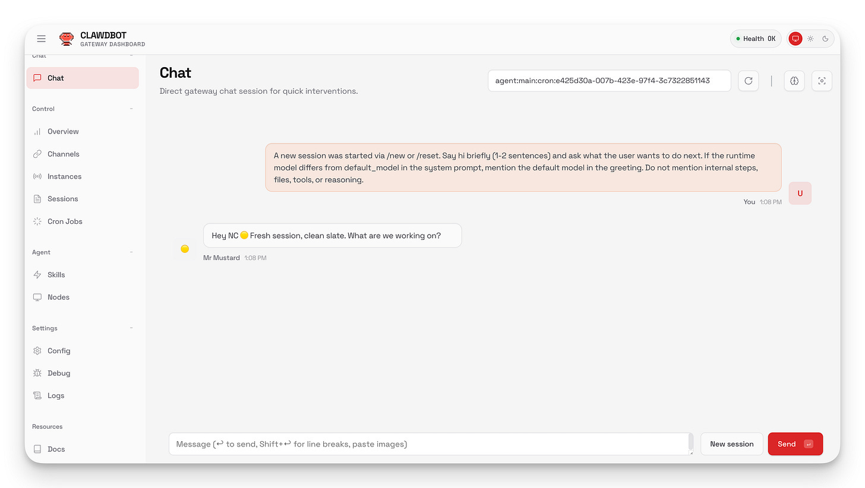

How To Create Your Telegram Agent
Once running, you get a web dashboard at your server's IP.
You can chat with your assistant right there, or connect WhatsApp/Telegram for mobile access.
I recommend you select “Telegram bot” as your channel. You’ll need to run through a few steps here too, but again lean on Moltbot to guide you through it if your not sure what to do next.
For example, “Can you help me set up Telegram?”
Here’s how:
- Open Telegram and search @botfather
- Send the command “/newbot”
- Create a name for you new Telegram bot
- Copy the token and your new Telegram bot name and give it to Moltbot
This makes sure only you can talk to your bot.
Moltbot will asks you a few questions to get started.
- What should I call you?
- What should you call me?
- What’s my purpose?
- What timezone are you in?
Once you answer these your new Telegram bot is ready.
Again, if you get stuck. Ask Moltbot for help.
From here you can start to configure your new bot. This includes installing skills which is essentially connecting different apps and services like 1Password, Apple Notes, and Notion.
Browse the skills directory here.

Here’s A Couple Prompts To Try First:
Before building anything complex, try a few commands to see Moltbot in action.
These take seconds.
- Check the weather: “What’s the weather looking like in Scottsdale, Arizona today?”
- Scout for content ideas: “What are people complaining about in r/Entrepreneur today that I could write about?”
Once you get a feel for how Moltbot works, I recommend you start with something simple, like a Daily Briefing.
Instead of connecting everything at once, ask Moltbot what you need to get your job done. It will recommend the services you need to connect and it will guide you through the process.

How To Build A Daily Marketing Brief
I used Moltbot to build a daily AI news briefing delivered to my Telegram every morning at 8am.
Moltbot has a built-in scheduler so you can schedule tasks that run automatically.
My daily briefing job fires at 8am ET and:
- Searches Twitter for “AI agents min_faves:100 within_time:24h”
- Fetches Reddit’s top daily posts from my favorite subreddits
- Hits the Hacker News API for recent AI discussions
- Compiles everything into a formatted brief
- Sends it to my Telegram first thing in the morning
This took a couple iterations of back and forth with Moltbot.
The first version was too corporate. I added engagement filters in the second version. Then in the third version I refined the prompt to “Focus on launches, new builds, hot takes.”
Here’s a snapshot of my report from this morning:

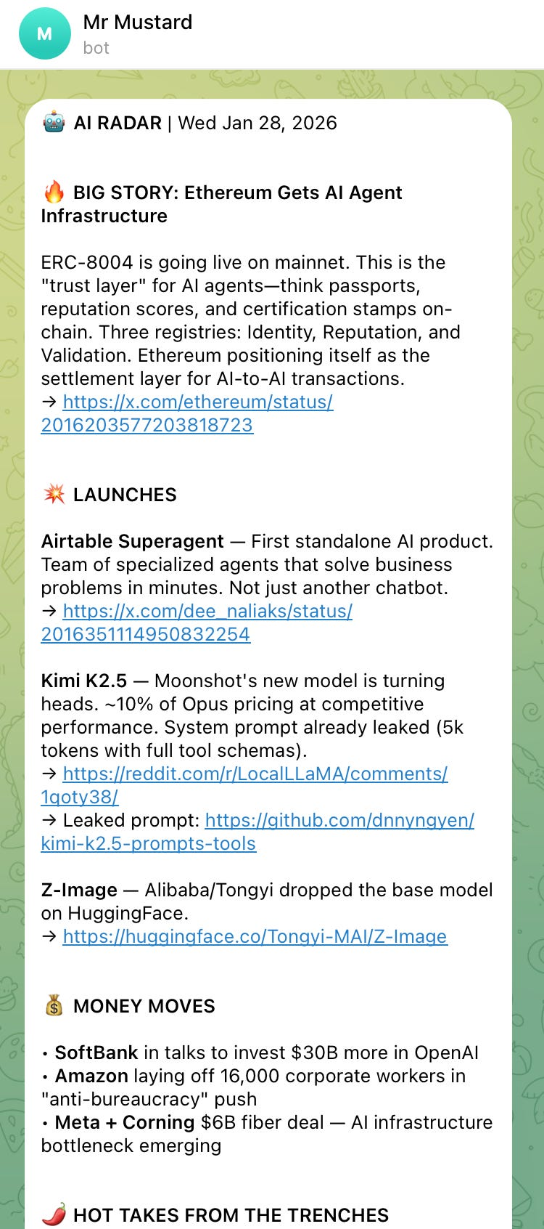

You’ll need 2 skills to do this for yourself.
- Bird to browse X
- Brave to browse the internet
If you want to create something similar, here’s a starter prompt you can feed Moltbot for your own daily briefing:
I want you to create a daily briefing that runs every morning at 8am.

It should:

1. Search X/Twitter for posts about [YOUR TOPIC] with at least 100 likes from the last 24 hours
2. Check the top posts from r/[YOUR SUBREDDIT] from today
3. Search Hacker News for anything related to [YOUR TOPIC]

Compile everything into a short briefing with links

Send it to me on Telegram
Replace [You Topic] and [Your Subreddit] with whatever you care about.
For freelance writers, that might be:
- Topic: “freelance writing” or “content marketing”
- Subreddits: r/freelancewriters, r/copywriting, r/content_marketing
Moltbot will ask you to set up Brave Search and Bird (for Twitter) if you haven’t already. Just follow the instructions.

Is Moltbot Right For You?
Yes, if:
- You’re comfortable clicking around a web dashboard
- You have $6/month for hosting and ~$10/month for API credits
- You want to understand where personal AI is headed
Maybe wait if:
- “API key” sounds intimidating
- You’re worried about security
- You need things to just work without any tinkering
The one-click setup removes most of the technical barrier. The hard part isn’t installation — it’s figuring out what to build. For this I recommend joining the Discord and taking inspiration from other creators.
If you set one up, let me know what you build.

